Paper Title (16 Bold)

Author (14)
¹Department of Zoology, Faculty of Science
²Department of Phy and Computer Science, Faculty of Science
Dayalbagh Educational Institute, Dayalbagh, Agra, INDIA
Corresponding Author: xxxx.(10)

ABSTRACT (10 Bold)
---------------------------------------------------------------------------------------------------------------------------------------
Date of Submission: xx-xx-xxxx Date of acceptance: xx-xx-xxxx
---------------------------------------------------------------------------------------------------------------------------------------

- INTRODUCTION (10 Bold)
Ecologists have synthesized various methods for effective conservation to save the threaten species across the globe. ‘Effective’ conservation needs to fulfill the demands of demography of the species, the distributions and associated wildlife management. In order to sustain the system of the conservation the centralized approaches must be intermingled multipart with the objective conservation. Objective conservation tactic will work as applied methodology consisting population viability analysis, threat evaluation and case based solutions. One approach for conservation could be developing ecological risk assessment framework.
Researchers have developed various frameworks for ecological risk assessment. The ecological risk assessment framework of United States Environmental Protection Agency was used by Diamond and Serveiss (2001) to structure a watershed-scale analysis of human land use, in-stream habitat quality, and their relationship to native fish and mussel populations in order to develop future management strategies and prioritize areas in need of enhanced protection. Using a generalizable risk assessment approach and statistical models of fish introductions into the Great Lakes, North America, Kolar and Lodge (2002) developed a quantitative approach to target prevention efforts on species most likely to cause damage. Higgins et al. (2003) summarized sources of uncertainty for migration forecasts and developed a method for managing uncertainty for risk assessment.Garcia-Alonso et al. (2006) proposed a tiered approach for conducting non-target organism risk assessment for genetically modified (GM) plants in Europe. The industry-wide approach developed by EuropaBio is based on the fundamental steps of risk evaluation, namely hazard and exposure assessment. Hope (2006) reviewed the development of the ecological risk assessment paradigm in the United States, and identified ways it is being applied and adapted in other countries. Linkov, Satterstrom, Steevens, Ferguson and Pleus (2007) combined state-of-the-art research in multi-criteria decision attribute (MCDA) methods applicable to nanotechnology with a hypothetical case study for nanomaterial management. The example shows how MCDA application can balance societal benefits against unintended side effects and risks, and how it can also bring together multiple lines of evidence to estimate the likely toxicity and risk of nanomaterials given limited information on physical and chemical properties. Burger (2008) studied method for assessment and management of risk to wildlife from cadmium. The background against which ecological risk assessment and management has developed was discussed by Power and McCarty (2008) and recent trends in the development of risk assessment and management frameworks are documented. Seven frameworks from five different countries are examined. Ankley et al. (2010) discussed adverse outcome pathway (AOP). An AOP is a conceptual construct that portrays existing knowledge concerning the linkage between a direct molecular initiating event and an adverse outcome at a biological level of organization relevant to risk assessment. Bulmana et al. (2011) developed an approach to progress the EBFM mandate in Australia, using a new ecological risk assessment framework applied to fisheries, termed Ecological Risk Assessment for the Effects of Fishing (ERAEF). Novel features of this framework include its hierarchical structure and its precautionary approach to uncertainty.
To create a realistic model of the natural population and their related threats a methodology is generated in this paper, which applies the principles of population analysis, threat identification, and risk impact determination.

- MATERIAL AND METHODS (10 Bold)
This section presents the phase-wise description of the developed risk-impact assessment methodology.

Phase I: Comprehensive Populace Monitoring to determine conservation strategies
Direct monitoring was conducted which gives a detail population count and measure of aves that are of conservation interest, such as types of species, abundance of single species, the species is local or migrant.)

Phase II:Identifying threats that imperiled avian species in a semi-arid zone
The disturbance gradients at the study site are identified on the basis of bio-geographical classification of birds, site-monitoring, vegetation structure, dietary habits, and population trend. This helps in identifying the threats to birds and habitats.

Phase III:Formation of Expert Assessment (EA) Team
The EATeam includes 9 - 10 experts from different fields (academicians, policy makers, ornithologists, and field experts). Their responsibilities include:
- rating and ranking the questionnaires; and
- giving their valuable opinions to ensure the reliability of the data

Phase IV: Determining the Risk Impact
The flow of the method is as shown in Figure 1. Following are the steps of the determining risk impact for the birds:
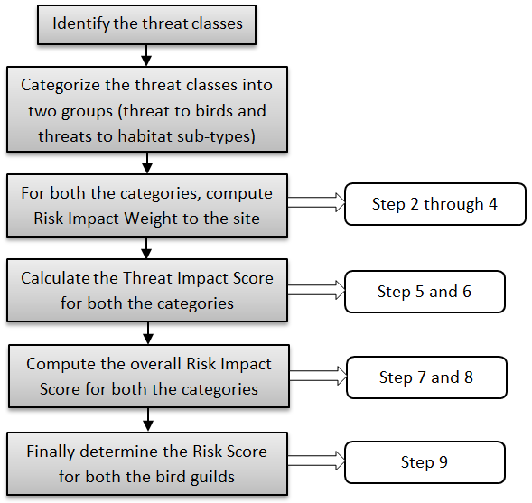
Figure 1: The flow of the methodology

Step 1: Identify t threat classes and group these into j categories to get $C_{t}^{j}$, where $C_{t}^{j}$ are the threats in each category.
Step 2: Score these$C_{t}^{j}$ to get the Threat Influence Score ${\left({SC}_{t}^{j}\right)}_{i}$for each t in every j and at each study site i. The scoring is done by EA Team using 5-point scale (High-5, Middle-3, and Low-1).
Step 3: Computation of Threat Influence Weights ${\left({WC}_{t}^{j}\right)}_{i}$ using following sub-steps:
Step 3.1 Fuzzy pairwise comparison of each $C_{t}^{j}$ by the EA Team using the Fuzzy Scale (Table 1).
Step 3.2: Conversion of fuzzy scale in triangular fuzzy number (TFN)${\tilde{a}}_{t}=\left(a_{1t}, a_{2t}, a_{3t}\right)$using 9-point fuzzy scale (Table 1). The triplet $\left(a_{1t}, a_{2t}, a_{3t}\right)$ represents the lower, middle and upper TFNfor the threat t.

Table 1: 9-point fuzzy scale
Fuzzy Scale | Triangular fuzzy scale | Description
$$\tilde{1}$$ | (1,1,1) if diagonal  (1,1,3) for equal importance | Equal importance
$$\tilde{3}$$ | (1, 3, 5) | Moderate importance of one over another
$$\tilde{5}$$ | (3, 5, 7) | Strong importance of one over another
$$\tilde{7}$$ | (5, 7, 9) | Very strong importance of one over another
$$\tilde{9}$$ | (7, 9, 9) | Extreme importance of one over another
$$\tilde{2}, \tilde{4}, \tilde{6}, \tilde{8}$$ | (1, 2, 4), (2, 4, 6), (4, 6, 8), (6, 8, 9) | Intermediate values

Step 3.3: Formation of Fuzzy Decision Matrix by aggregating the scores of the EA Team members using equation
(1)

Step 3.4: Compute Fuzzy Decision Weights $\left({\tilde{F}}_{t}\right)$using equation
(2)

Step 3.3: Computation of Decision Weights $\left(D_{t}\right)$for the Fuzzy Decision Weights using the equation
, (3)

Where
represents the left value of -cut for , and
represents the right value of -cut for .

Step 3.4: Determining the Threat Influence Weights by normalizing $D_{t}$

Step 4: Determining the Site-Risk Impact Weights ${\left({RC}_{t}^{j}\right)}_{i}$for the study sites using the equation
$${\left({RC}_{t}^{j}\right)}_{i}={\left({SC}_{t}^{j}\right)}_{i}×{\left({WC}_{t}^{j}\right)}_{i}$$ | (4)

Step 5: Score the $C_{t}^{j}$according to their timing (Table 2), range (Table 3) and severity (Table 4) in relation to how likely these ‘trigger’ the bird species mortality at the study site i, to get Threat Trigger Scores ${\left({TC}_{t}^{j}\right)}_{i}$ (Equation (5)). The scoring is done by the EA Team members.
$${\left({TC}_{t}^{j}\right)}_{i}=TS+RS+SeS$$ | (5)

Table 2: Timing of threat
Timing of threat | Timing score (TS)
Happening now | 5
Likely in short term (within 4 years) | 3
Likely in long term (beyond 4 years) | 1
Past (and unlikely to return) and no longer limiting | 0

Table 3: Range of threat
Range of threat | Range score (RS)
Whole population/area (>90%) | 5
Most of population/area (50-90%) | 3
Some of population/area (10-50%) | 1
Few individuals/small area (<10%) | 0

Table 4: Severity of threat
Severity of threat | Severity score (SeS)
Rapid deterioration (>30% over 7 years) | 5
Moderate deterioration (10–30% over 7 years) | 3
Slow deterioration (1–10% over 7 years) | 1
No or imperceptible deterioration (<1% over 7 years) | 0

Step 6: Now score the species and habitat sub-type against each $C_{t}^{j}$to get the Threat Influence Score for k species ${\left({IC}_{t}^{j}\right)}_{i}^{k}$ and for l habitat sub-types ${\left({IC}_{t}^{j}\right)}_{i}^{l}$.The scoring is done by EA Team using 5-point scale (High-5, Middle-3, and Low-1).

Step 7: Computing the Total Threat Impact Score${\left(T{IC}_{t}^{j}\right)}_{i}^{k}$using the equation
$${\left({TIC}_{t}^{j}\right)}_{i}^{k} ={\left({IC}_{t}^{j}\right)}_{i}^{k}×{\left({TC}_{t}^{j}\right)}_{i}$$ | (6)

and total habitat threat impact score ${\left(T{IC}_{t}^{j}\right)}_{i}^{l}$using the equation
$${\left({TIC}_{t}^{j}\right)}_{i}^{l} ={\left({IC}_{t}^{j}\right)}_{i}^{l}×{\left({TC}_{t}^{j}\right)}_{i}$$ | (7)

Step 8: Calculating the overall Risk Impact Score ${\left({ORC}_{t}^{j}\right)}_{i}^{k}$for each category using the equation
$${\left({ORC}_{t}^{j}\right)}_{i}^{k}={\left({TIC}_{t}^{j}\right)}_{i}^{k}×{\left({WC}_{t}^{j}\right)}_{i}$$ | (8)
and
$${\left({ORC}_{t}^{j}\right)}_{i}^{l}={\left({TIC}_{t}^{j}\right)}_{i}^{l}×{\left({WC}_{t}^{j}\right)}_{i}$$ | (9)

- CASE STUDY: ANALYZING THREATS TO AVIAN DIVERSITY OF SEMI-ARID ZONE AGRA (INDIA) (10 Bold)
This section presents the threat assessment of avian diversity for a semi-arid region of India, Agra.The city, Agra, is situated on the banks of the river Yamuna in eastern Uttar Pradesh (India) with geographic coordinates 27°.11' latitude North and 78°.02' longitude East. The climate of Agra features a semi-arid climate that borders on humidity in monsoon, dry weather in summers and mild to bit chilly winters. The city temperature varies between1°C to 45°C.
The area is a highly biota-sensitive zone. The wildlife here is very rich, which is preserved at many formal and informal habitats. The major formal bird hotspot of Agra is the SoorSarovar Bird Sanctuary which comes under protected area (IUCN Category IV, Protected Areas). In spite of the increasing urban pressure all around the area, this site is able to sustain the Aves up to some extent due to a mix of aquatic habitat, forests, semi-arid zone, river and cultivations.
SoorSarovar Bird Sanctuary(SBS) is a small sanctuary, comprising of fresh water wetland known as Keetham Lake which is the biggest lake of Uttar Pradesh. The site is known for preserving the matrix of patches such as agricultural, terrestrial, marshy, riverine etc. The sanctuary has breeding grounds for many aquatic bird species on account of permanent deep lake with surrounding forest.The site also showcases the occupancy for the majority of special status species.

Figure 2: The SoorSarovar Sanctuary

The semi-arid landscapes of SBSand their various environmental aspects (as discussed with the EA Team) comprising of tropical dry deciduous vegetation and humid subtropical climate (Table 1), are evaluated using the Rapid Eco-regional Assessment (REA) Methodology (Carr et al., 2013). The overarching environmental changes within thehabitats was also assessed which includes climate change, invasive species, and urban growth.The habitats were also assessed to understand their ecological condition, floral trends, prospects for green reserves conservation and restoration.

Table 5: Attributes assessed for REA of the study site(Source: Meteorological Department of Agra)
S.No. | Attributes
1. | Temperature | Average 2.0°C – 45.6°C
2. | Rainfall | 203.3 mm
3. | Humidity | Average – 56
5. | Species Inventory (self-observation)
5. | Area value (self-observation)
6. | Vegetation (self-observation)

3.1 Survey Design
Habitats of the study site
Habitats of the study site were visited multiple times from July 2009 to July 2015 to conduct an immense field work. The site was studied thoroughly between 6 to 9 am; 12 to 2 pm; and 4 to 6 pm. Study sites were divided into quadrates to calculate the ecological data of the habitat. A total of 8 quadrates of one square kilometer were analyzed in the habitat. The quadrates were compared to analyze different environmental variables (landscape structure, landscape heterogeneity, resources, and biotic information) in the habitat. The areas within the quadrates were then divided into strata, which were first individually counted that later was summed for the entire area.

The structure of the habitat was divided into the first, second and third-levels of habitat framework which represents the level changes within the habitat.

Table 6: Hierarchy of habitat at SBS
First Level | Second Level | Third Level
Grassland | Dry Savanna, Moist Savanna
Scrubland | Xeric Shrubs | Dense foliage cover, Mid-dense foliage cover, Sparse foliage cover
Forest | Tropical Dry Forest | Saplings, Mature tree, Old-growth
 | Tropical Seasonal Forest | Saplings, Mature tree
 | Tropical thorn forests | Saplings, Mature tree
Bare Ground | Sand Dunes, Semi-arid Plains
Urban Landscape | Farms, Gardens
Wetlands | River | Upstream, Low stream, River Bank
 | Lake/Pond | Perennial, Annual, Seasonal
 | Marshes | Seasonal marshes, Permanent marshes
 | Canal | Perennial, Annual, Seasonal

Suitability of above habitats was analyzed on the basis of the following criteria:

Table 7: Description of the selected criteria
S.No. | Criteria | Description
1. | Demographic conditions of the habitat | The present absent data of the species and frequency of rare species
2. | Temporal geography | It concern the periodic geography of the pre and post habitat fragmentation
3 | Habitat quality | Considers habitat types that are suitable for a species
5. | Seasonal habitat change
5. | Food availability | Considers availability of food for the species considered in the patch
6. | Nesting availability | Considers availability of food for the species considered in the patch
7. | Proximity to water | Considers stagnant or running freshwater sources, e.g., ponds, lakes, rivers in the patch or within the travel distances of an organism
8. | Arbitrary threats to the habitat | Pressure and threats due to land use change and development activities, and all other unwanted activities impacting wildlife (In RAPPAM)

Aves of the study site
The birds were surveyed from August 2009 to July 2015 using direct count, focal and 1-0 scan sampling methods. The habitats of SBS were stratified into 1 × 1 km grids using standard point count method. Birds were recorded in four grids, each grid of 50 m. A total of 8 sampling sites were laid down randomly within the grids of each study site. Surveys were conducted in the morning hours from 6.00 a.m. to 9.30 a.m. and evening hours from 4.00 p.m. to 5.00 p.m. by the Observer. Samplings were also made on seasonal basis and the field characteristics were noted down on ornithological sampling data sheet which included species, number of individuals, activities, micro-habitat, threats to birds and other details.
Sampling points for the calculations were selected as their importance level (lake surroundings, near water canal, near adjacent river bank, inside the forest). These samplings sites were either present at the edges of core zones or in buffer zones of the study site.
Observations were also made according to the generic and species level. In case of line transect method observation was performed through a straight line (50 m breadth and 500 m length). Random and direct counting was performed for several times.

  - Identifying the threats that imperil avian species in Agra
A list of possible disturbance gradients to the study site was compiled (Table 8) and was presented to the EA Team for analyzing the applicability of each disturbance gradient to the birds at the study site.

Table 8: Disturbance Gradient
Disturbance Gradient | Applicable to Birds | Likely to affect population trends within next 5 years?
Poaching | Yes | Yes
Trading | Yes | Yes
Hunting | Yes | Yes
Vehicular Pollution | Yes | Yes
Chemical run off | Yes | Yes
Sewage and drain water | Yes | Yes
Electrocution | Yes | Yes
Air collision | Yes | Yes
Building collision | Yes | Yes
Transmission | Yes | Yes
Parasitic | Yes | Yes
Bacterial | Yes | Yes
Deforestation | Yes | Yes
Loss of Buffer zone | Yes | Yes
Habitat encroachment | Yes | Yes
Industrialization | Yes | Yes
Building construction | Yes | Yes
Recreational activities | Yes | Yes
Residential expansions | Yes | Yes
Noise disturbance | Yes | Yes
Off road vehicle | Yes | Yes
garbage disposal | Yes | Yes
Sand mining | Yes | Yes
Fishing | Yes | Yes
Water development | Yes | Yes
Live-stock grazing | Yes | Yes
Predation | Yes | Yes
Inter/intra species competition | Yes | Yes
Disaster | Yes | Yes
Temperature | Yes | Yes
Research | No | N/A
Defense activities | No | N/A

The disturbance gradients were grouped into threat classes. The resulting list displayed in Table 9, as agreed by the Team, formed the basis for the risk assessment.

Table 9: Threat classes
Threat Class | Disturbance gradient | Type | Population components affected
Wildlife Crime | Poaching | Direct | Eggs, Juveniles, Adults
 | Trading | Direct | Eggs, Juveniles
 | Hunting | Direct | Adults
Pollution | Vehicular Pollution | Indirect | Juveniles
 | Chemical run off | Indirect | Eggs, Juveniles
 | Sewage and drain water | Indirect | Eggs, Juveniles
Collision | Electrocution | Direct | Adults
 | Air collision | Direct | Adults
 | Building collision | Direct | Adults
Emerging infectious disease | Transmission | Direct | Juveniles, Adults
 | Parasitic | Direct | Adults
 | Bacterial | Direct | Eggs, Juveniles, Adults
Habitat Fragmentation | Deforestation | Direct | Adults
 | Loss of Buffer zone | Direct | Eggs, Juveniles, Adults
 | Habitat encroachment | Direct | Eggs, Juveniles, Adults
Human intervention | Industrialization | Direct | Adults
 | Building construction | Direct | Eggs, Juveniles, Adults
 | Recreational activities | Direct | Juveniles, Adults
 | Residential expansions | Direct | Eggs, Juveniles, Adults
Tourism | Noise disturbance | Direct | Adults
 | off road vehicle | Direct | Adults
 | garbage disposal | Direct | Juveniles, Adults
Over exploitation | Sand mining | Indirect | Eggs
 | Fishing | Indirect | Eggs
 | Water development | Indirect | Eggs, Juveniles
 | Livestock grazing | Indirect | Eggs, Juveniles, Adults
Natural threats | Predation | Direct | Eggs, Juveniles, Adults
 | Inter/intra species competition | Direct | Adults
 | Disaster | Direct | Eggs, Juveniles
 | Temperature | Direct | Eggs, Juveniles

The threat classes were divided into two categories (j = 2):
- Threats direct to the birds$\left(C_{t}^{1}\right)$: These are the threats that are directly affecting the birds.
- Threats to the habitats$\left(C_{t}^{2}\right)$: These are the threats affecting the habitats and thus are affecting the birds also.

Table 10: Threat Categories
Bird Threats | Habitat Threats
Wildlife Crime (WC) | Pollution (Pol)
Collision (C) | Habitat fragmentation (HF)
Emerging infectious disease (EID) | Human intervention (HI)
Human intervention (HI) | Tourism (T)
Tourism (T) | Over exploitation (OE)
Natural threats (NT) | Natural threats (NT)

3.3 Determining the Risk Impact
Step 1: Each $C_{t}^{j}$ was scored as shown in Table 10helped in computation of Threat Influence Score ${\left({SC}_{t}^{j}\right)}_{i}$as shown in Table 11.

Table 10: $C_{t}^{1}$Scoring
WC | H
C | M
EID | M
HI | H
T | H
NT | H

Table 11:${\left({SC}_{t}^{1}\right)}_{i}$
WC | 5
C | 3
EID | 3
HI | 5
T | 5
NT | 5
Step 3: Determine Threat Influence Weights ${\left({WC}_{t}^{j}\right)}_{i}$ using following steps:
Fuzzy pairwise comparison of$C_{t}^{j}$was done to determine the triangular fuzzy number:

Table 12: Triangular fuzzy number for category 1
 | WC | C | EID | HI | T | NT
WC | 1 | (5,7,9) | (1,3,5) | (1,1,3) | (1,3,5) | (3,5,7)
C |  | 1 | (1/4,1/2,1) | (1/8,1/6,1/4) | (1,1,3) | (1,3,5)
EID |  |  | 1 | (1/8,1/6,1/4) | (1/4,1/2,1) | (1,3,5)
HI |  |  |  | 1 | (3,5,7) | (3,5,7)
T |  |  |  |  | 1 | (1,2,4)
NT |  |  |  |  |  | 1

Next the Fuzzy Decision Matrix was formed (Table 13) by aggregating expert comparisons.

Table 13: Fuzzy decision matrix
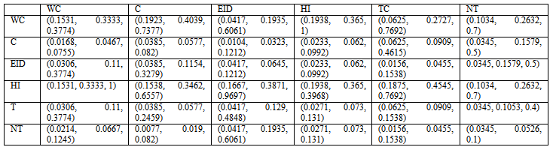
The Fuzzy Decision Matrix helped in computing the Fuzzy Decision Weights $\left({\tilde{F}}_{t}\right)$

${\tilde{F}}_{t}$for category 1
WC | (0.1478, 0.3530, 0.7278)
C | (0.0444, 0.0964, 0.2086)
EID | (0.0483, 0.1203, 0.2735)
HI | (0.2041, 0.4101, 0.7653)
T | (0.0602, 0.1283, 0.3225)
NT | (0.0373, 0.0886, 0.1992)

This helped in calculating the Decision Weights $\left(D_{t}\right)$.

$D_{t}$for category 1
WC | 0.3954
C | 0.1114
EID | 0.1406
HI | 0.4474
T | 0.1598
NT | 0.1034

The Threat Influence Weights ${\left({WC}_{t}^{j}\right)}_{i}$ were determined by normalizing $D_{t}$

$${\left({WC}_{t}^{1}\right)}_{i}$$
WC | 0.2911
C | 0.0821
EID | 0.1035
HI | 0.3294
T | 0.1177
NT | 0.0762

Step 4: ${\left({RC}_{t}^{j}\right)}_{i}$was computed using equation (4).

Table 12: ${\left({RC}_{t}^{j}\right)}_{i}$for category 1
WC | C | EID | HI | T | NT
1.456 | 0.246 | 0.311 | 1.647 | 0.588 | 0.381

Step 5: Threat trigger scores of site are as given below:

Table 13:Trigger Score
 | WC | C | EID | HI | T | NT
TS | 3 | 5 | 3 | 5 | 5 | 5
RS | 5 | 5 | 3 | 5 | 5 | 5
SeS | 5 | 3 | 3 | 5 | 5 | 3

These were used to calculate ${\left({TC}_{t}^{j}\right)}_{i}$
Table 14:${\left({TC}_{t}^{j}\right)}_{i}$
WC | C | EID | HI | T | NT
13 | 13 | 9 | 15 | 15 | 13

Step 6: $C_{t}^{j}$ were scored by the EA Team using Threat Impact Questionnaire (Appendix I) to get the Threat Influence Score ${\left({IC}_{t}^{j}\right)}_{i}^{k}$ for the bird species

Table 16: ${\left({IC}_{t}^{j}\right)}_{i}^{k}$
Bird Code | Species | WC | C | EID | HI | T | NT
PPPs282 | Alexandrine Parakeet | 5 | 1 | 3 | 1 | 5 | 1
PCDi173 | Ashy Drongo | 1 | 1 | 1 | 1 | 1 | 1
PCPr168 | Ashy Prinia | 1 | 1 | 1 | 1 | 1 | 1
CCEu110 | Asian Koel | 1 | 1 | 1 | 1 | 1 | 1
CCAn083 | Asian Openbill | 1 | 1 | 1 | 1 | 1 | 1
AACy021 | Asian Palm Swift | 1 | 1 | 1 | 3 | 5 | 1
PCTe174 | Asian Paradise Flycatcher | 1 | 1 | 1 | 1 | 1 | 1
PSSt246 | Asian Pied Starling | 1 | 1 | 5 | 1 | 1 | 1

Step 7: Total species threat impact score ${\left(T{IC}_{t}^{j}\right)}_{i}^{k}$is calculated using the equation (6)

Table 17${\left(T{IC}_{t}^{j}\right)}_{i}^{k}$ for few birds
Bird Code | Species | WC | C | EID | HI | T | NT
PPPs282 | Alexandrine Parakeet | 45 | 7 | 18 | 9 | 45 | 3
PCDi173 | Ashy Drongo | 9 | 7 | 6 | 9 | 9 | 3
PCPr168 | Ashy Prinia | 9 | 7 | 6 | 9 | 9 | 3
CCEu110 | Asian Koel | 9 | 7 | 6 | 9 | 9 | 3
CCAn083 | Asian Openbill | 9 | 7 | 6 | 9 | 9 | 3
AACy021 | Asian Palm Swift | 9 | 7 | 6 | 27 | 45 | 3
PCTe174 | Asian Paradise Flycatcher | 9 | 7 | 6 | 9 | 9 | 3
PSSt246 | Asian Pied Starling | 9 | 7 | 30 | 9 | 9 | 3

Step 8: The Overall Risk Impact Score ${\left({ORC}_{t}^{j}\right)}_{i}^{k}$was calculated for category 1 using the equation (8)

Table 18: ${\left({ORC}_{t}^{j}\right)}_{i}^{k}$for few birds
Bird Code |  | Wildlife Crime | Collision | Emerging infectious disease | Human intervention | Tourism | Natural threats
PPPs282 | Alexandrine Parakeet | 65.50349 | 1.723086 | 5.590742 | 14.82488 | 26.47789 | 1.142523
PCDi173 | Ashy Drongo | 13.1007 | 1.723086 | 1.863581 | 14.82488 | 5.295578 | 1.142523
PCPr168 | Ashy Prinia | 13.1007 | 1.723086 | 1.863581 | 14.82488 | 5.295578 | 1.142523
CCEu110 | Asian Koel | 13.1007 | 1.723086 | 1.863581 | 14.82488 | 5.295578 | 1.142523
CCAn083 | Asian Openbill | 13.1007 | 1.723086 | 1.863581 | 14.82488 | 5.295578 | 1.142523
AACy021 | Asian Palm Swift | 13.1007 | 1.723086 | 1.863581 | 44.47463 | 26.47789 | 1.142523
PCTe174 | Asian Paradise Flycatcher | 13.1007 | 1.723086 | 1.863581 | 14.82488 | 5.295578 | 1.142523
PSSt246 | Asian Pied Starling | 13.1007 | 1.723086 | 9.317903 | 14.82488 | 5.295578 | 1.142523

Similarly ${\left({ORC}_{t}^{j}\right)}_{i}^{l}$was computed. Finally the ${ORC}_{t}^{j}$were calculated for all bird guilds.

Table 19:${\left({ORC}_{t}^{j}\right)}_{i}^{l}$for habitats of SBS
 | Pol | HF | HI | T | OE | NT
B-Sand Dunes | 1.177516 | 10.51237 | 13.21773 | 1.126962 | 26.16754 | 3.062612
B-Semi arid Plains | 1.177516 | 31.53712 | 39.6532 | 3.380886 | 26.16754 | 3.062612
F-Mature tree TDF | 3.532547 | 52.56186 | 66.08867 | 3.380886 | 43.61256 | 3.062612
F-Mature tree TSF | 1.177516 | 31.53712 | 39.6532 | 3.380886 | 26.16754 | 3.062612
F-Mature tree TTF | 3.532547 | 52.56186 | 39.6532 | 5.63481 | 26.16754 | 3.062612
F-Old-growth TDF | 3.532547 | 52.56186 | 66.08867 | 5.63481 | 43.61256 | 3.062612
F-Saplings TDF | 1.177516 | 31.53712 | 39.6532 | 1.126962 | 8.722512 | 3.062612
F-Saplings TSF | 1.177516 | 10.51237 | 13.21773 | 1.126962 | 8.722512 | 3.062612
F-Saplings TTF | 1.177516 | 10.51237 | 13.21773 | 1.126962 | 26.16754 | 3.062612
G-Dry Savanna | 1.177516 | 31.53712 | 66.08867 | 1.126962 | 43.61256 | 3.062612
G-Moist Savanna | 3.532547 | 52.56186 | 39.6532 | 3.380886 | 43.61256 | 3.062612
SC-Dense foliage cover | 1.177516 | 52.56186 | 66.08867 | 1.126962 | 43.61256 | 3.062612
SC-Mid-dense foliage cover | 1.177516 | 31.53712 | 13.21773 | 1.126962 | 26.16754 | 3.062612
SC-Sparse foliage cover | 1.177516 | 10.51237 | 39.6532 | 1.126962 | 8.722512 | 3.062612
U-Farms | 3.532547 | 10.51237 | 66.08867 | 3.380886 | 26.16754 | 3.062612
U-Gardens | 1.177516 | 31.53712 | 66.08867 | 1.126962 | 43.61256 | 3.062612
W-Annual C | 3.532547 | 31.53712 | 39.6532 | 3.380886 | 26.16754 | 3.062612
W-Annual L/P | 3.532547 | 31.53712 | 39.6532 | 5.63481 | 26.16754 | 3.062612
W-Low stream | 3.532547 | 52.56186 | 66.08867 | 3.380886 | 43.61256 | 9.187835
W-Perennial C | 5.887578 | 31.53712 | 66.08867 | 5.63481 | 43.61256 | 3.062612
W-Perennial L/P | 5.887578 | 31.53712 | 66.08867 | 5.63481 | 26.16754 | 3.062612
W-Permanent marshes | 3.532547 | 31.53712 | 39.6532 | 3.380886 | 26.16754 | 3.062612
W-River Bank | 3.532547 | 31.53712 | 13.21773 | 1.126962 | 26.16754 | 3.062612
W-Seasonal C | 3.532547 | 10.51237 | 13.21773 | 1.126962 | 8.722512 | 3.062612
W-Seasonal L/p | 1.177516 | 10.51237 | 13.21773 | 1.126962 | 8.722512 | 3.062612
W-Seasonal marshes | 1.177516 | 10.51237 | 13.21773 | 1.126962 | 8.722512 | 3.062612
W-Up stream | 5.887578 | 52.56186 | 39.6532 | 5.63481 | 43.61256 | 9.187835

These threats are also affecting the birds. Thus the computed overall Risk Impact Score for the bird guilds are

Table 20: ${ORC}_{t}^{j}$for bird guilds
 | Pol | HF | HI | T | OE | NT
Primary Forest birds | 17.66274 | 87.6031 | 110.1478 | 28.17405 | 72.6876 | 9.187835
Water birds | 29.43789 | 52.56186 | 110.1478 | 28.17405 | 72.6876 | 9.187835
Grassland bird | 17.66274 | 87.6031 | 110.1478 | 16.90443 | 72.6876 | 1.837567
Deep Forest Bird | 5.887578 | 87.6031 | 110.1478 | 16.90443 | 72.6876 | 5.512701
Shore birds | 29.43789 | 87.6031 | 66.08867 | 28.17405 | 43.61256 | 9.187835
Scrubland bird | 17.66274 | 52.56186 | 66.08867 | 16.90443 | 43.61256 | 1.837567
Urban birds | 29.43789 | 52.56186 | 110.1478 | 5.63481 | 43.61256 | 1.837567
Marshes birds | 17.66274 | 87.6031 | 66.08867 | 16.90443 | 14.53752 | 1.837567

- RESULTS (10 Bold)
The computed risk impact score helped in determining the birds risk impact. The birds and habitats were divided into three risk categories: High Risk (affected by 2 or more threats), Intermediary Risk (affected by one type of threat), and Low Risk (birds under pressure).

Threats to Habitats
Mature tree, old growth, dry and moist savanna, dense foliage cover, gardens, low stream, upstream, annual and perennial canals are among constant threat of Habitat Fragmentation (${\left(T{IC}_{t}^{1}\right)}_{1}^{1}:$ 52.56), Human Intervention (${\left(T{IC}_{t}^{1}\right)}_{1}^{1}:$66.09) and Over Exploitation (${\left(T{IC}_{t}^{1}\right)}_{1}^{1}:$43.61) with significant level of risk impact. Sand dunes, saplings, mid dense foliage cover, river bank and seasonal canal, lake and ponds and marshes are under pressure.
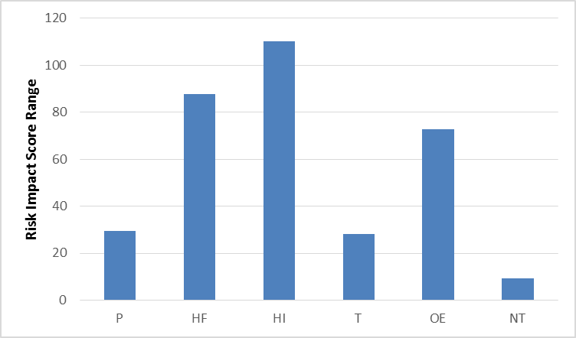
Figure3: Risk Impact Range

The elucidation of the chart is based on types of risks and how much they impact the birds’ population of the SBS. Habitat Intervention is the highest while Natural Threat is affecting only for short term. Habitat Intervention will not only affect the birds but also it’s after affects would be much high.

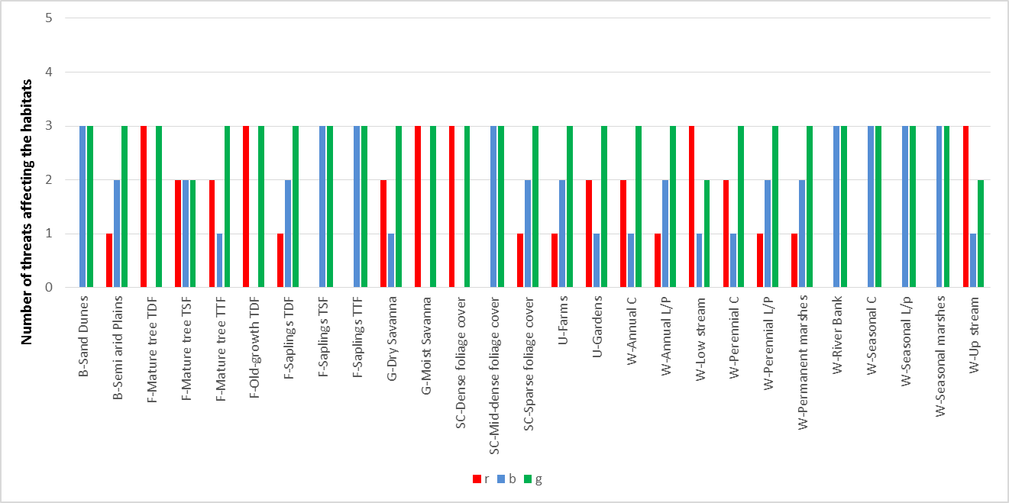
Figure4: Threats to SBShabitats

Figure 4 is a detail illustration of multiple threats that are direct or indirect, and for long term or short term are affecting the birds’ habitat. The impact comparison shows that mature trees, old growths of native forest, grassland’s moist savannah and scrubland’s dense foliage are under equal threats. In wetlands, low stream and upstream, river is in under habitat depletion.

Threats to Birds
Human Intervention(${ORI}_{c_{2}}^{z_{1}}:$74.12) and Wildlife Crimes (${ORI}_{c_{2}}^{z_{1}}:$ 65.50) are the main risks at this site. 37 birds, out of 243, are locally extinct here, and 32 birds are at a high risk.Forest birds, grassland birds, scrubland birds, and bare ground birds are the most threatened guilds at SBS and other are at immediacy risk. These two threats are followed by unplanned Tourism in the natural site.
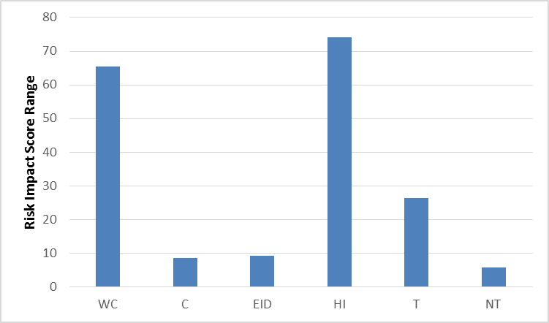
Figure5: Risk Impact Range (bird threats)

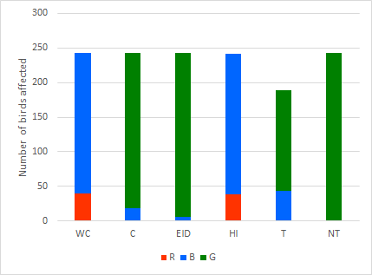
Figure6: Threats to birds at SBS

The interpretation of Figure 6 reveals the number of birds that are being affected from the threats. Wildlife Crime and Habitat Interventions stood on the same level as the threatened number of birds are almost equal and the risk impact of these threats is also the same. Only natural threats are even among all the birds and persists no long term problems for the aves.

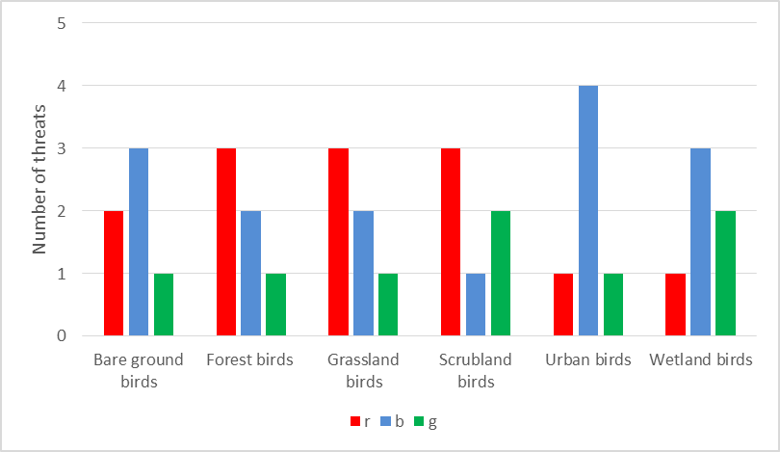
Figure7: Threats to bird guilds at SBS

Figure 7 depicts which varieties of birds, based on their habitat preference, are being affected by the threats. It further reflectsthe category of birds that are suffering from single type of threat and the category that goes as high as surviving against 4 threats.

The above results demonstrate that almost all the birds of the study site are at threatened. To analyze the reasons for this, management effectiveness of the site was evaluated using RAPPAM (Ervin, 2003). The relatively high market value of land and the ease of access make the site vulnerable.

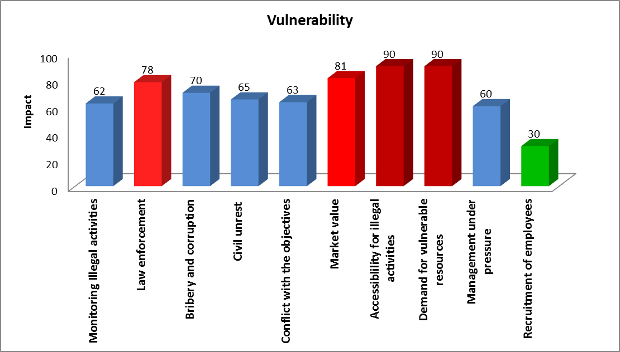
Figure 8: Vulnerability at SBS

Output points out that the main problem here is lack of law enforcement. Degree of efforts for site restoration and mitigation should also be taken in account. The PA is suffering from laxity of staff and habitat negligence. Infrastructure development, related to wildlife protection and conservation are also needed.

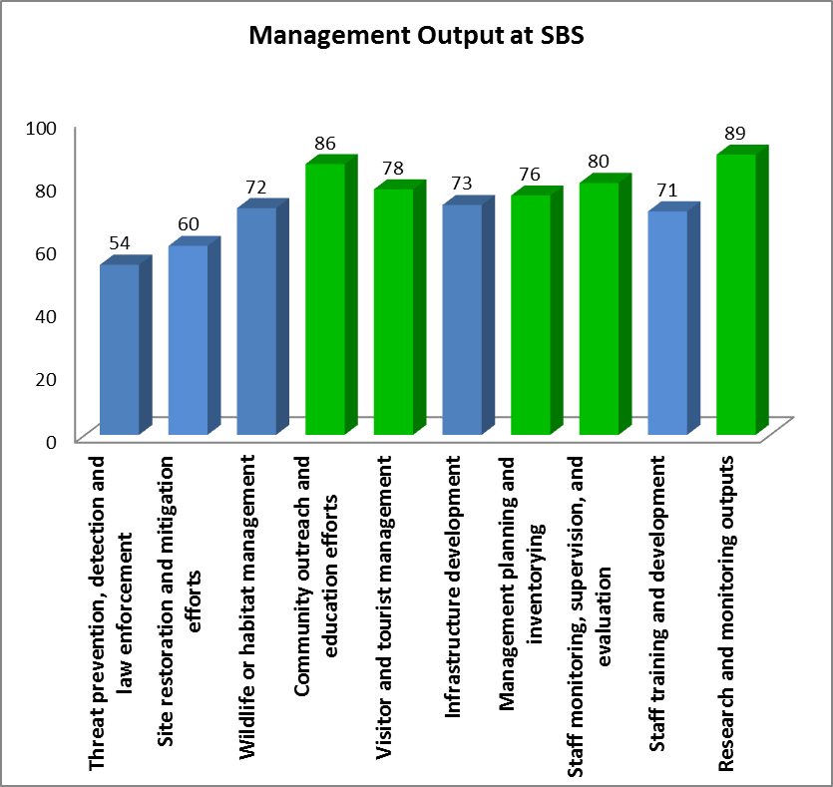
Figure 9: Management output

- DISCUSSION AND CONCLUSION (10 Bold)
The developed RIA methodology offers a realistic approach to assess ecological risks. It takes into account uncertainty in the analysis. The method is interactive and has the advantage of bringing stakeholders, scientists and managers together to develop management solutions. The scientific development of ecological risk assessment methodology serves as a useful environmental management tool.The main goal of the model is to determining the risk impacts of threats of the study sites which will help in determining local conservation status, disturbance gradients, birds that are most threatened and the priority areas for conservation.

REFERENCES (10 Bold)
- Ankley, G.T., Bennett, R. S., Erickson, R. J., Hoff, D. J., Hornung, M. W., et al. 2010. Adverse Outcome Pathways: A Conceptual Framework to Support Ecotoxicology Research and Risk Assessment. Environmental Toxicology and Chemistry, 29:3, 730–741.
- Burger, J. 2008. Assessment and management of risk to wildlife from cadmium. Science of the Total Environment. 389:1, 37–45.
- Carr, N.B., Garman, S.L., Walters, A., Ray, A., Melcher, C.P., et al. (2013). Wyoming Basin Rapid Ecoregional Assessment work plan: U.S. Geological Survey Open-File Report58, 2013–1223. http://dx.doi.org/10.3133/ofr20131223.ISSN 2331-1258

Diamond, J. M. and Serveiss, V. B. 2001.Identifying Sources of Stress to Native Aquatic Fauna Using a Watershed Ecological Risk Assessment Framework.Environ. Sci. Technol., 35 (24), pp 4711–4718.DOI: 10.1021/es0015803.

Ervin, J. (2003). WWF: Rapid Assessment and prioritization of Protected Area Management (RAPPAM) Methodology. WWF Gland, Switzerland WWF.
- Garcia-Alonso, M., Jacobs, E., Raybould, A., Nickson, T. E., Sowig, P., et al. 2006. A tiered system for assessing the risk of genetically modified plants to non-target organisms. Environ. Biosafety Res. 5, 57–65 DOI: 10.1051/ebr:2006018.
- Higgins, S. I., Clark, J. S., Nathan, R., Hovestadt, T., Schurr, F., et al. (2003), Forecasting plant migration rates: managing uncertainty for risk assessment. Journal of Ecology, 91: 341–347. doi:10.1046/j.1365-2745.2003.00781.x
- Hobdaya, A. J., Smitha, A.D.M., Stobutzki, I. C., Bulman, C., Daleya, C. R., et al. 2011. Ecological risk assessment for the effects of fishing. Fisheries Research 108 (2011) 372–384.
- Hope, B. K. 2006. An examination of ecological risk assessment and management practices. Environment International. 32(8):983–995
- Kolar, C. S. and Lodge, D. M. 2002. Ecological Predictions and Risk Assessment for Alien Fishes in North America, Science 298, 1233. DOI: 10.1126/science.1075753
- Linkov, I. Satterstrom, F. K., Steevens, J., Ferguson, E. and Pleus, R. C. 2007. Multi-criteria decision analysis and environmental risk assessment for nanomaterials. Journal of Nanoparticle Research 9:543–554. DOI 10.1007/s11051-007-9211-0.
- Power, M. and McCarty, L.S. 2010. Trends in the Development of Ecological Risk Assessment and Management Frameworks. 7-18 http://dx.doi.org/10.1080/20028091056683

Appendix I
Threat Impact Questionnaire

This questionnaire is prepared to identify threats and its levels for the wild birds in study area.

Instruction to fill the questionnaire
Give score to each threat from 0 – 5 on the basis of how much the threat is affecting the birds in the given time.

Timing of threat
Timing of threat | Timing score (TS)
Happening now | 5
Likely in short term (within 4 years) | 3
Likely in long term (beyond 4 years) | 1
Past (and unlikely to return) and no longer limiting | 0

Bird Code | Bird | Wildlife Crime | Collision | Emerging infectious disease | Human intervention | Tourism | Natural threats
PCDi173 | Ashy Drongo
PCPr168 | Ashy Prinia
CCEu110 | Asian Koel
CCAn083 | Asian Openbill
AACy021 | Asian Palm Swift

Give score to each threat from 0 – 5 on the basis of threat range and how much population is being affected

Range of threat
Range of threat | Range score (RS)
Whole population/area (>90%) | 5
Most of population/area (50-90%) | 3
Some of population/area (10-50%) | 1
Few individuals/small area (<10%) | 0

Bird Code | Bird | Wildlife Crime | Collision | Emerging infectious disease | Human intervention | Tourism | Natural threats
PCDi173 | Ashy Drongo
PCPr168 | Ashy Prinia
CCEu110 | Asian Koel
CCAn083 | Asian Openbill
AACy021 | Asian Palm Swift

Give score to each threat from 0 – 5 on the basis of how much the threat is affecting the birds and causing species depletion.

Severity of threat
Severity of threat | Severity score (SeS)
Rapid deterioration (>30% over 7 years) | 5
Moderate deterioration (10–30% over 7 years) | 3
Slow deterioration (1–10% over 7 years) | 1
No or imperceptible deterioration (<1% over 7 years) | 0

Bird Code | Bird | Wildlife Crime | Collision | Emerging infectious disease | Human intervention | Tourism | Natural threats
PCDi173 | Ashy Drongo
PCPr168 | Ashy Prinia
CCEu110 | Asian Koel
CCAn083 | Asian Openbill
AACy021 | Asian Palm Swift

